Transforming transport & mobility in Scotland

Primary schools’ challenge

Institute of the Motor Industry & SMTA activity project mapped to the Scottish curriculum for excellence.

About this challenge

**Inspiring and supporting your learners to make well informed decisions about their future and assisting you to embed Careers Education, Information, Advice and Guidance into your school FREE of charge.**

This challenge supports young people to start to think about their next steps after school and embeds careers education into the curriculum alongside being mapped to the Scottish curriculum for excellence.

Pupils are asked to undertake four key tasks including researching, reimagining, planning, and pitching, based around a sustainability and mobility focus which asks teams to invent a new form of vehicle. It’s also designed to be fun!

The challenge also supports pupils in their soft and employability skills by using teamwork, communication, and reasoning throughout.

We have some fantastic prizes available for the winning school, these will be listed on the SMTA website as we progress the competition.

Entries start Autum of 2024 and judging will be in the Spring of 2025 with the winners being announced soon after the judging is completed.

This competition is kindly sponsored by the SMTA.

Curriculum contents

This activity is directly linked to the Scottish Curriculum for Excellence and encompasses the following sections:

|  |
| --- |
| **1) Expressive arts**   * Be creative and express themselves in different ways. * Experience enjoyment and contribute to other people’s enjoyment through creative and expressive performance and presentation.   **2) Religious and moral education**   * Develop the skills of reflection, discernment, critical thinking and deciding how to act when making moral decisions. * Make a positive difference to the world by putting their beliefs and values into action. * Establish a firm foundation for lifelong learning, further learning and adult life.   **3) Health and wellbeing**   * Make a successful move to the next stage of education or work.   **4) Sciences**   * Recognise the role of creativity and inventiveness in the development of the sciences. * Establish the foundation for more advanced learning and, for some, future careers in the sciences and technologies. * Express opinions and make decisions on social, moral, ethical, economic and environmental issues based upon sound understanding.   **5) Languages**   * Develop a secure understanding of how language works and develop their capacity to communicate ideas and information in English and other languages. * Exercise their intellectual curiosity by questioning, developing their understanding, thinking creatively and critically to synthesise ideas and arguments. * Communicate, collaborate and build relationships. * Reflect on and explain my literacy and thinking skills, using feedback to help me improve and sensitively provide useful feedback for others. * Engage with and create a wide range of texts in different media, taking advantage of the opportunities offered by ICT.   **6) Social studies**   * Engage in activities which encourage enterprising attitudes. * Develop an understanding of concepts that encourage enterprise and influence business. * Establish firm foundations for lifelong learning and for further specialised study and careers.   **7) Numeracy**   * Appreciate how the imaginative and effective use of technologies can enhance the development of skills and concepts.   **8) Technologies**   * Awareness of technological developments (Past, Present and Future), including how they work. * Impact, contribution, and relationship of technologies on business, the economy, politics, and the environment. * Using digital products and services in a variety of contexts to achieve a purposeful outcome. * Designing & constructing models/products. * Representing ideas, concepts and products through a variety of graphic media. |

About the IMI

The Institute of The Motor Industry is the professional body for individuals working in the motor industry and the authoritative voice of the retail automotive sector. The IMI’s aim is to ensure that the automotive retail sector has a skilled, competent, and professional workforce that is fully equipped to keep pace with the demands of new technology and changing markets. A key part of business for manufacturers and dealers is to encourage the best and brightest people to join their business in a variety of roles.

The automotive industry influences everyone, from delivering goods on time to commuters travelling to work and emergency services being able to respond to a crisis, the motor industry helps to keep the country moving. IMI Autocity is the one-stop-shop for impartial careers information and advice on careers in the Retail Motor Industry. Whether you are an individual looking to start or progress your career, or a teacher or careers advisor who supports others in making their career choices, Autocity is the place to start. With over 200 #MotorCareers to choose from Autocity provides you with all things Automotive!

[www.theimi.org.uk/autocity](http://www.theimi.org.uk/autocity)

About the SMTA

**ENCOURAGE, PROMOTE & PROTECT**

The SMTA was formed in 1903 to “encourage, promote and protect” the interest of our, at that time, small band of members. To this day that statement remains our reason to exist. Our job is to look after the interests of all our members whether it’s the largest motor group in the country or whether it’s a small MOT station or even just a one-person operation in a remote part of the country.  
  
Our business is your business; we are member owned and member driven and have been ever since our inception way back in 1903. However, from being very much an association in our earlier years which was there to help when things went wrong, we have now become a modern 21st century business, but still owned and driven by our members and their needs.

www.smta.co.uk/about-the-smta/

Activity lesson plan – Primary schools

The automotive industry helps everyone, from delivering food and medicine on time, helping people travel to work and emergency services being able to help in a crisis, the motor industry helps to keep the country moving.

Automotive means everything on the UK roads that we use to transport people and things. This includes cars, lorries, motorbikes, busses, electric scooters, vans, and tractors.

The IMI helps people working in the motor industry and the SMTA look after the interests of all their members whether it’s the largest motor group in the country or whether it’s a small MOT station or even just a one-person operation in a remote part of the country.

Together we have been working hard to prepare the industry for the future, but we have run out of ideas! So, we need your help to create a brand-new vehicle that will be ready for 2035 specifically designed for Scotland.

Can you imagine what type of vehicles will be popular in 2035? What will they look like? Will they have some fun things in them that haven’t been invented yet?

Follow the steps below and help us design a vehicle of the future for Scotland.

Pupil activity pack

|  |  |
| --- | --- |
| School name |  |
| Year group |  |
| Team participants | 1.  2.  3.  4.  5.  6. |

The Competition is kindly sponsored by the SMTA.

STEP 1: What challenges do we face and how can you overcome them.

Think about where you live and what the unique challenge you might face in moving from place to place in Scotland. Write up some key points below.

|  |
| --- |
|  |

Now think about some of the new technology you can invent to tackle and overcome some of these challenges with your new vehicle. Consider how the new technology will this affect the envirment in your local area?

|  |  |
| --- | --- |
| The Challenge… | The new Technology to help… |

Here are some ideas to get you started…

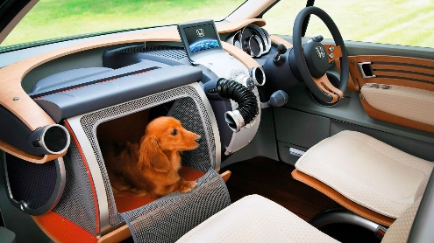 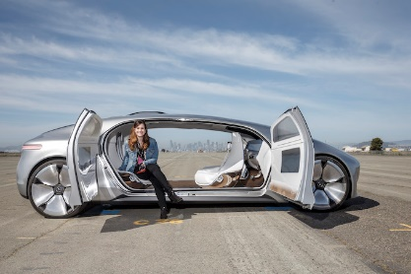 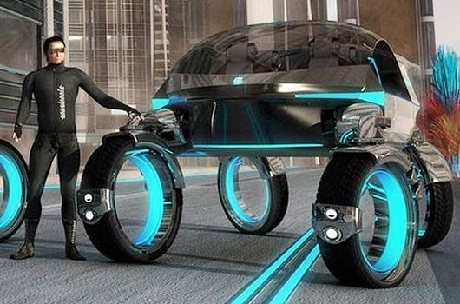

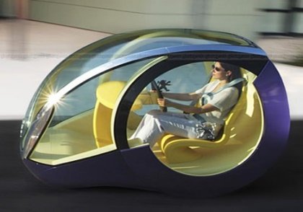 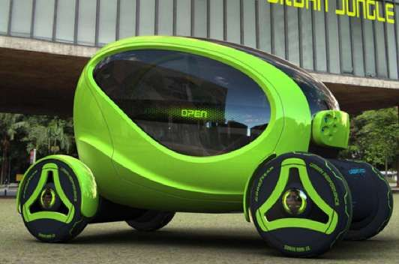 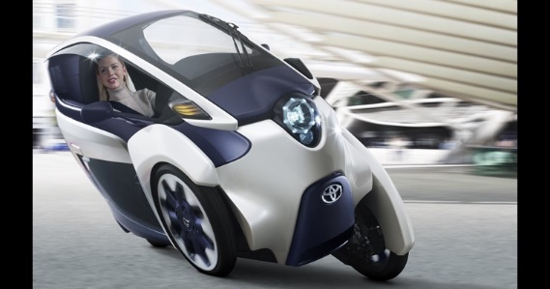

STEP 2: Design

Sketch your new vehicle to overcome those challenge, highlighting the new technology you have invented and developed to overcome any challenges you identified.

|  |
| --- |
|  |

Create a poster to advertise your transport of the future.

|  |
| --- |
|  |

STEP 3: Branding

Brand your vehicle, create a logo that represents the new technology and create a strapline to see your vehicle on the poster.

|  |
| --- |
| Create a logo. |

|  |
| --- |
| Create a strapline. |

STEP 4: Pitch

Either share your poster design in class, you can record you talking though your ideas or simply send in your entry to [careers@theimi.org.uk](mailto:careers@theimi.org.uk)